Inventory Module Setup Processes

AiM 8.5 (browser access)

2016

Table of Contents

Inventory Concept 2

Warehouse Setup 3

Inventory Classification 6

Cycle Code 8

Manufacturer 9

Inventory Part Profile 10

Warehouse Bin Definition 14

Inventory Adjustment 17

Inventory Adjustment – Initial Entry 18

Inventory Adjustment – Quantity Change 19

Inventory Adjustment – Cost Change 20

Inventory Concept

The Inventory Module is designed to maintain and control on hand inventory in a warehouse. This packet will walk through the steps of setting up the inventory and maintaining costs and counts.

There are multiple parts to Inventory. They must be setup in this order.

1. Warehouse Definition
2. Inventory Classification
3. Cycle Code (Optional based on warehouse processes)
4. Manufacturer
5. Inventory Part Profile
6. Warehouse Bin Definition
7. Inventory Adjustment

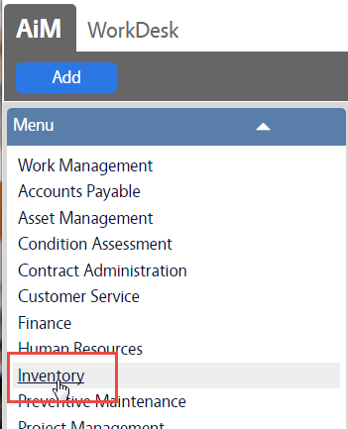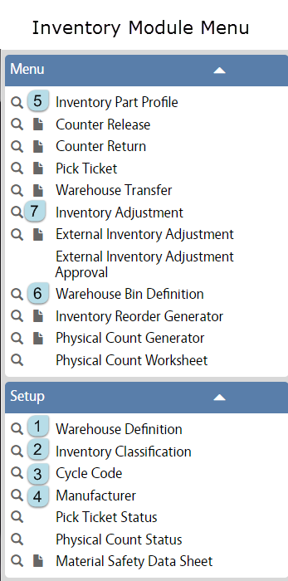

Warehouse Setup

|  |  |  |
| --- | --- | --- |
|  | * In the Inventory Module, look at the Setup menu * Click the Paper Icon  next to Warehouse Definition | |
|  | * Click New | |
|  | | |
|  | 1. In the yellow bar, Name the warehouse. *This cannot be changed once saved.* 2. In the next box, describe the warehouse. | |
|  | 1. In the next block, enter the location of the warehouse | |
|  | 1. These questions determine how requests are processed for this warehouse.  * See explanations below | |
| * *Active* – Is this warehouse in use * *Disable Release/Returned To Validation* – This effects the Counter Release and Counter Return Screens. If set to YES, the shop person in the released to field and returned by field must be setup as a Shop Person in the Human Resources Module. * *Validate Shop* – If set to YES, the released to person on the Counter Release Screen must belong to the shop on the Work Order Phase. * *Disable Pick Ticket User Validation* - If set to YES, shop people do not have to be listed on the Warehouse Security Screen in order to create a Pick Ticket. | | |
|  | 1. Account Setup  * Click on Account Setup in the View Menu | |
| * Add an Offset Account (Account that will receive funds) * Add a Charge Account (Account that will pay for parts purchased) * Click | | |
|  | 1. Back on the Warehouse Definition screen, click Security on the View Menu | |
| * Load the user role that will have access to make transactions for this warehouse. * Click | | |
|  | | * Click |

Inventory Classification

Inventory Classification is a hierarchy of class, commodity, and item. This hierarchy is used to classify parts according to their characteristics and function.

Classifications must be created before setting up Inventory Parts.

|  |  |
| --- | --- |
|  | * In the Inventory Module, look at the Setup menu * Click the Paper Icon  next to Inventory Classification |
| 1. Class – this is the highest level of the hierarchy. 2. Click Add to go to Commodity | |
| 1. Commodity – There can be multiple Commodities in a Class. 2. Click Add to go to Inventory Item | |
| 1. Inventory Item – Last part of hierarchy. Can be multiple Inventory Items under a Commodity. *This is not the part number.* 2. Click  to return to the Commodity screen or  to create additional Inventory Items. | |
| * If  was clicked, the Commodity screen will reappear. * Click  to return to the Classification screen or  to create additional Commodities. * Continue this process until all of the Commodity and Item combinations for this Classification have been setup. | |
| * Once all Commodity and Items are created, click  to return to the Classification page. * Click | |

Cycle Code

Cycle Code is used to separate inventory parts into groups for cycle counting. These groups could be based on the frequency they need to be counted. This is optional, but if cycle counting will be used, the codes must be created before they can be added to the Inventory Part Profile screen.

|  |  |
| --- | --- |
|  | * In the Inventory Module, look at the Setup menu * Click the Paper Icon  next to Cycle Code |
| 1. Code identifier 2. Description of the code (ex: quarterly counts) 3. Active – Yes or No 4. Click | |
|  | |

Manufacturer

Manufacturer is the maker of the parts. Manufacturer is used for Inventory, Assets and Equipment.

|  |  |
| --- | --- |
|  | * In the Inventory Module, look at the Setup menu * Click the Paper Icon  next to Manufacturer |
|  | |
| 1. Name - In the red box, enter the identifier for the manufacturer. This can be a name, abbreviation, or number. This must be unique to each manufacturer. 2. Desciption - Enter the full name of the manufacturer or a description of what they make. 3. Enter any contact information that is available for the manufacturer. 4. Click | |

Inventory Part Profile

The Inventory Part Profile screen is the main inventory control screen used to identify parts. These are items stored in warehouses.

|  |  |  |
| --- | --- | --- |
|  | | * In the Inventory Module, look at the main Menu * Click the Paper Icon  next to Inventory Part Profile |
|  | | |
| The Inventory Part Profile screen is divided into blocks, as highlighted by the green box. | | |
|  | 1. Title Block  * In the yellow, enter a unique part identifier. This identifier cannot be changed * The large box is for the description of the part. This description will appear on transaction screens. | |
|  | 1. Classification Block  * This aides in searching and reporting on parts * Click on the Magnify Glass in the Class field. | |
|  | * Choose a Class * The screen will advance to the available Commodities | |
|  | * Choose a Commodity * The screen will advance to the available Items | |
|  | * Choose the Item   *If there is only one selection available on any of these screens, the system will advance automatically. | |
|  | * After selecting an Item, the screen will return to the Inventory Part Profile screen. * The last selection is if the part is considered Green. | |
|  | 1. Attributes Block  * Type – Material is normal stock parts; Equipment are tools that can be “rented” to a work order. * Cycle Code is used to divide the warehouse into sections for cycle counting. (Must be chosen from list.) * Manufacturer (Must be chosen from list.) * Model – part model number * MSDS – MSDS data can be loaded into AiM and linked to the part. * MSDS Required - Yes or No | |
|  | 1. Active Block  * Active – Yes or No * UOM – How the item is released from the warehouse. (ex: each, foot, box) * UOM Fractional – Choose Yes for items such as wire that would could be released as 1 ½ feet. | |
|  | | |
| 1. Click  to add a picture of the part. | | |

|  |  |
| --- | --- |
|  | Additional Screens Available-   * Extra Description – Additional information on the part * Substitute parts – Can link to other inventory parts that can be used if this one is out of stock. * Vendors – Will list if a part is listed in a loaded Vendor catalog. * Warehouse – Will list which warehouse(s) and bin(s) the part is stored in * Kit Usage – Will list if the part is tied to a kit in AiM. |
| When all data has been entered, Click  on the main screen. | |

Warehouse Bin Definition

The Warehouse Bin Definition screen sets up the storage locations for a warehouse. This screen also defines parameters for reorder and physical counts.

|  |  |  |
| --- | --- | --- |
|  | | * In the Inventory Module, look at the main Menu * Click the Paper Icon  next to Warehouse Bin Definition |
|  | | |
|  | 1. Title Block  * The Red box is for the Bin identifier. Typical bin numbering system is *Section.Row.Shelf_Unit.Shelf.Bin*. * The Definition field is optional. | |
|  | 1. Active Block  * Active – Yes or No * Warehouse – choose warehouse from the created list * Part – Load the part number   *\*\* Each Bin can only contain 1 part. A part can be located in multiple bins.* | |
|  | 1. Quantities Block  * Quantity – This field is not editable. It will show the current number in stock once inventory is added. * Minimum Quantity * Maximum Quantity | |
| Reorder Level and Reorder Quantity or Target Level define how the Reorder Generator will function. There are 2 methods. Each are explained below.   1. Reorder Level & Reorder Quantity  * When inventory reaches the Reorder Level, the Inventory Reorder Generator will create an order for the Reorder Quantitiy. * Reorder level must be greater or equal to the Min Qty and less than the Max Qty. * Reorder Level + Reorder Quantity cannot equal more than the Max Qty.  1. Target Level  * Target Level replaces the Reorder Level and Quantity. Target Level should be a number between the minimum and maximum quatitities. * When inventory reaches the Target Level, the Inventory Reorder Generator will create an order for the amount of (Maximum Quantity – Quantity on Hand) | | |
|  | 1. Cycle Count Block  * Bin Order – If the part in kept in multiple bins, this number indicates the order the bins are pulled from. * Cycle Code – Autopopulates based on the Inventory Part Profile screen * Start Date – Date that Cycle Count should start * Frequency – Interval for counting this bin | |
|  | Reorder By Month   * On the View Menu, Click Reorder By Month | |
|  | | |
| * Reorder By Month allows the setup of different Reorder Levels and Reorder Quantities for each month. This accomodates periods of greater use. * Click  to return to the Warehouse Bin Definition screen | | |
| * Click | | |

Inventory Adjustment

The Inventory Adjustment screen is used to add the initial stock to a bin, to adjust the cost of a part without adding a quantity, and adjust quantity.

|  |  |
| --- | --- |
|  | * In the Inventory Module, look at the main Menu * Click the Paper Icon  next to Inventory Adjustment |
|  | There are 3 options –   * Quantity – Change just the number of items without the cost changing. * Cost – Change the cost without changing the quantity. * Initial Entry – Create the starting quantity and cost for a part. |
|  |  |

Inventory Adjustment – Initial Entry

|  |  |
| --- | --- |
|  | * Choose Intial Entry * Click |
|  | |
| 1. Title Block  * Transaction number is autogenerated. * The Description field is required. What is the purpose of this transaction. * Type – Set Price and Quantity (autopopulates)  1. Inventory Part Block  * Choose the Warehouse * Choose the Part number * Choose the Bin the parts are going into * Current Unit Cost – since this is the initial entry, it should be $0 * Currrent Quantitiy - since this is the initial entry, it should be 0  1. Adjustment Block  * Unit Cost – cost per item. * Quantity – how many are being entered * Total Cost – this will update once the record is saved  1. Click | |

Inventory Adjustment – Quantity Change

|  |  |
| --- | --- |
|  | * Choose Quantity * Click |
|  | |
| 1. Title Block  * Transaction number is autogenerated. * The Description field is required. What is the purpose of this transaction. * Type – Adj Qty (autopopulates)  1. Inventory Part Block  * Choose the Warehouse * Choose the Part number * Choose the Bin the parts are going into * Current Unit Cost – this amount will populate once the part is chosen * Currrent Quantitiy - this amount will populate once the part is chosen  1. Adjustment Block  * Unit Cost – not editable * Quantity – how many are being entered or taken away * Total Cost – this will update once the record is saved  1. Click | |

Inventory Adjustment – Cost Change

|  |  |
| --- | --- |
|  | * Choose Cost * Click |
|  | |
| 1. Title Block  * Transaction number is autogenerated. * The Description field is required. What is the purpose of this transaction. * Type – Adjust Price (autopopulates)  1. Inventory Part Block  * Choose the Warehouse * Choose the Part number * Bin does not appear on this transaction. * Current Unit Cost – this amount will populate once the part is chosen * Currrent Quantitiy - this amount will populate once the part is chosen  1. Adjustment Block  * Unit Cost – this amount will replace the current Unit Cost * Quantity – not editable * Total Cost – remains $0  1. Click | |