AiM 13.3

2023

Login Basics

Login = netid@tamu.edu

How to Create a Query

A Query is a saved search.

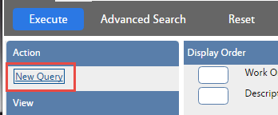

* Click *New Query*

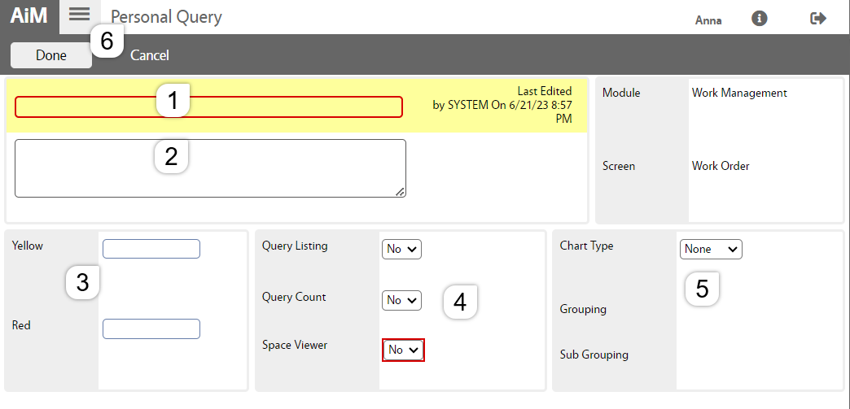

The Personal Query screen will open.

1. 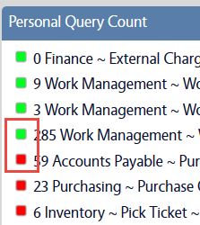Name the query. (This is the only required field.)
2. Describe what the query is searching for.
3. If a number is put in these fields, the green box in the query   
   channel on the WorkDesk will change colors once the number is met.
4. Query Count = Yes – This allows the query to appear on the WorkDesk
5. Chart options
6. Click *Done* to return to the Search screen

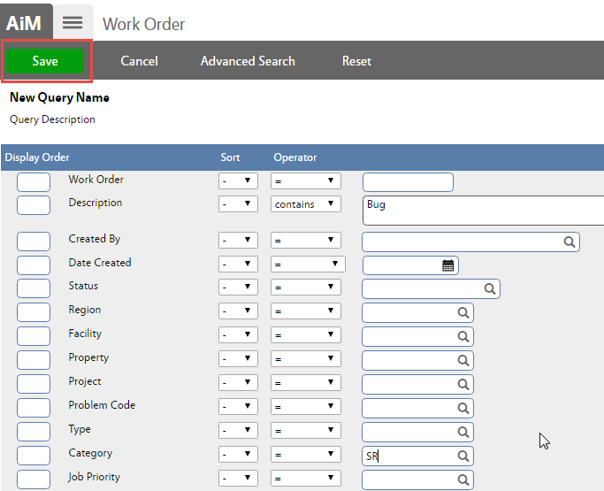

* Enter the criteria for the query
* Click  to save the criteria

Changes to Query settings, can be made from –

* System Administration
* Personal Query

Update WorkDesk

* Click 
* Choose layout option

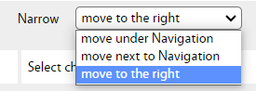

* Check Channels to show on the screen

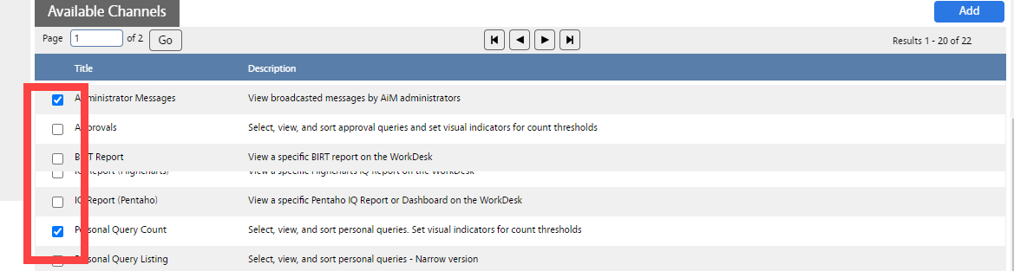

* Click 
* Update order of Channels

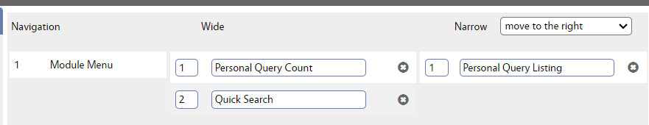

* Click 

**Edit Channel Settings**

* Click  to edit
* Options vary by Channel

